INSTALLATION GUIDELINES

XAMPP

1. First, click the following link <https://www.apachefriends.org/download.html> add download XAMPP which is suitable for your device.
2. Now, double click on the downloaded file to run the installation.
3. Click the OK button on the warning to continue.

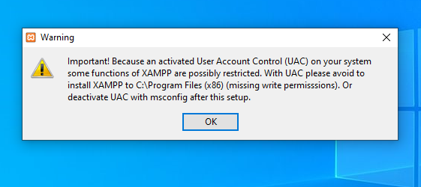

1. Click the Next button. 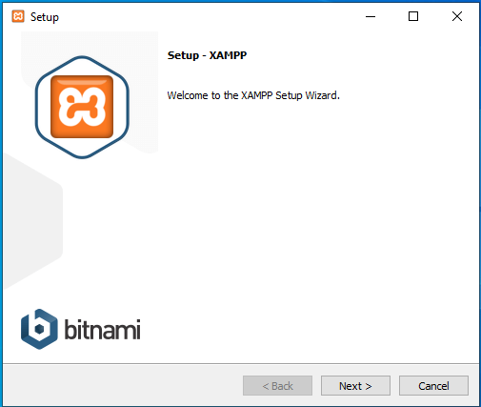
2. XAMPP offers a variety of services like Apache, MySQL, phpMyAdmin, and many more which are selected by default. It is recommended that you select everything as you will use all of them eventually and click Next. 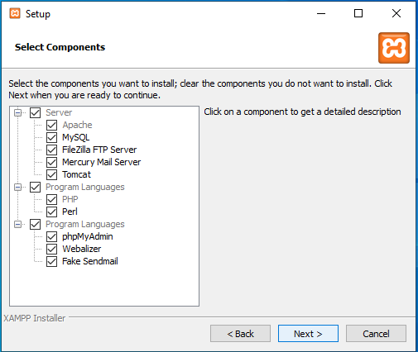
3. Now, select the location for the installation of the software. You can either choose the default location or choose it according to your own preference. After selecting the folder click Next.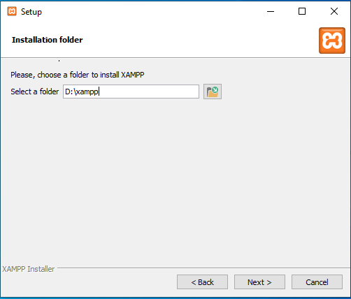

1. You will be asked if you want to learn more about bitnami which is a library of installers or software packages for web applications and solution stacks as well as virtual appliances. You can unclick the learn more checkbox and press Next. 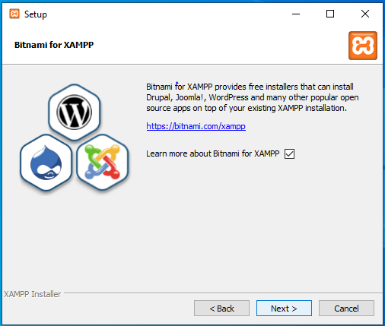
2. Now, wait for xampp to finish installing and click Next. 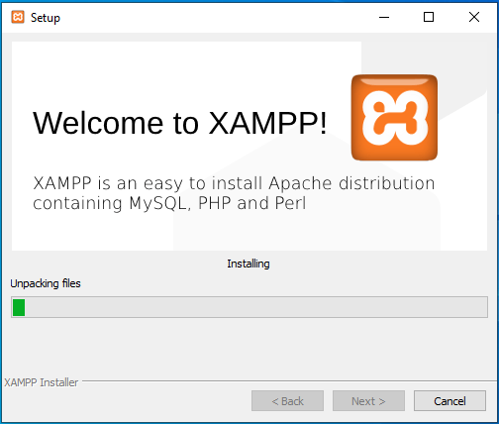
3. After the completion of installation XAMPP, it will ask you if you want to run the xampp control panel now. Leave the check box as it is and click on Finish. 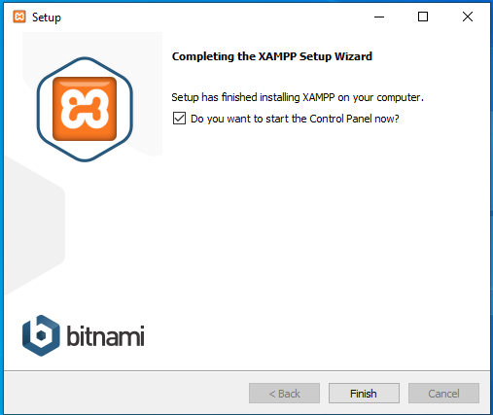
4. Click on the flag of the language you want to run. English is recommended and click on Save. 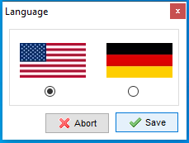
5. The Xampp control panel will start up if you had selected to start the control panel during step 9. You might receive an error telling you Tomcat will not start, but as we do not need tomcat it will not matter.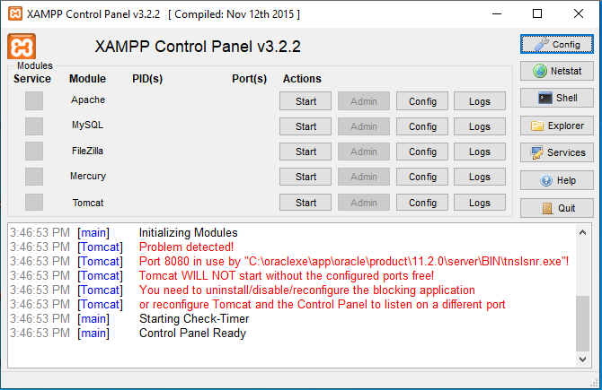
6. Click on the first Start alongside Apache to start the server. 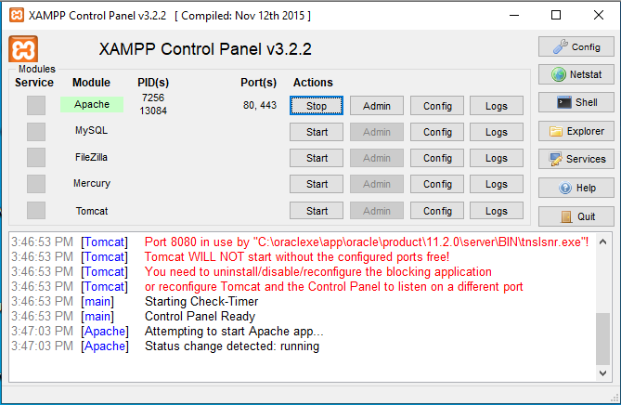

Oracle Database

1. First download “Oracle Database Express Edition 11g” from <https://www.oracle.com/database/technologies/appdev/xe.html>.
2. After the download has finished double click on it to run the downloaded file.
3. A window will open showing the installation, wait until the installation is completed.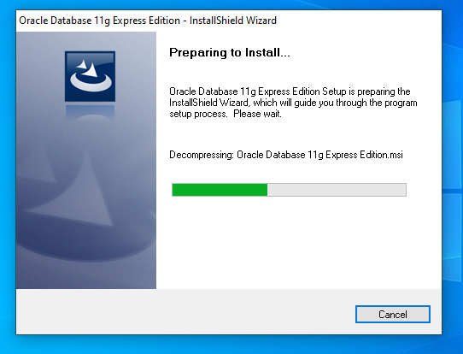
4. It will ask you if you want to repair or remove an existing installation if you already had it previously. Choose repair and click Next.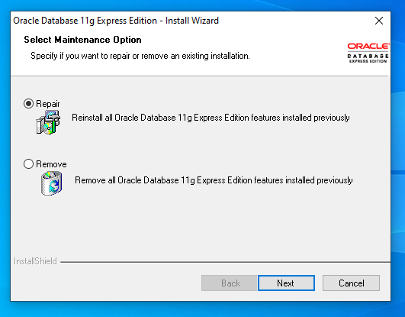
5. You will have to wait for the repair to complete.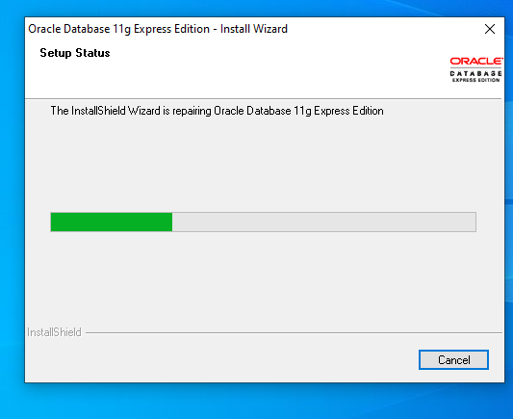
6. The window will inform you that the setup has been completed then click Finish.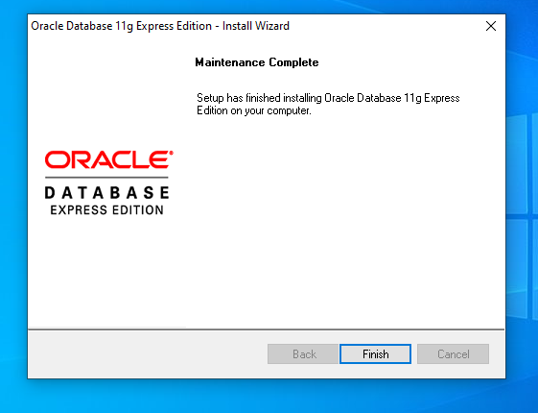

Oracle Database Update

1. In order to update oracle database to version 19.2 first we need to find the version number of our php, so go to the previously installed xampp folder and run ‘xampp shell’.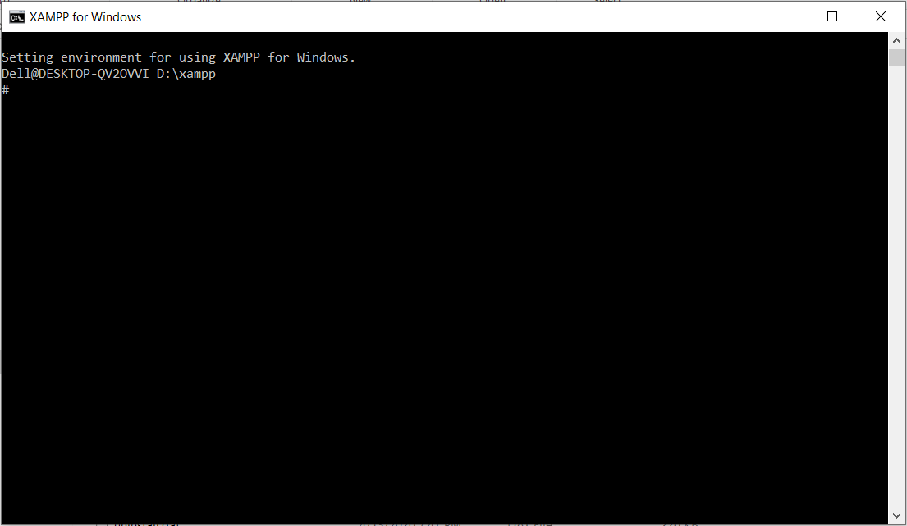
2. Type ‘php -v’ to find out the version of php you are using. 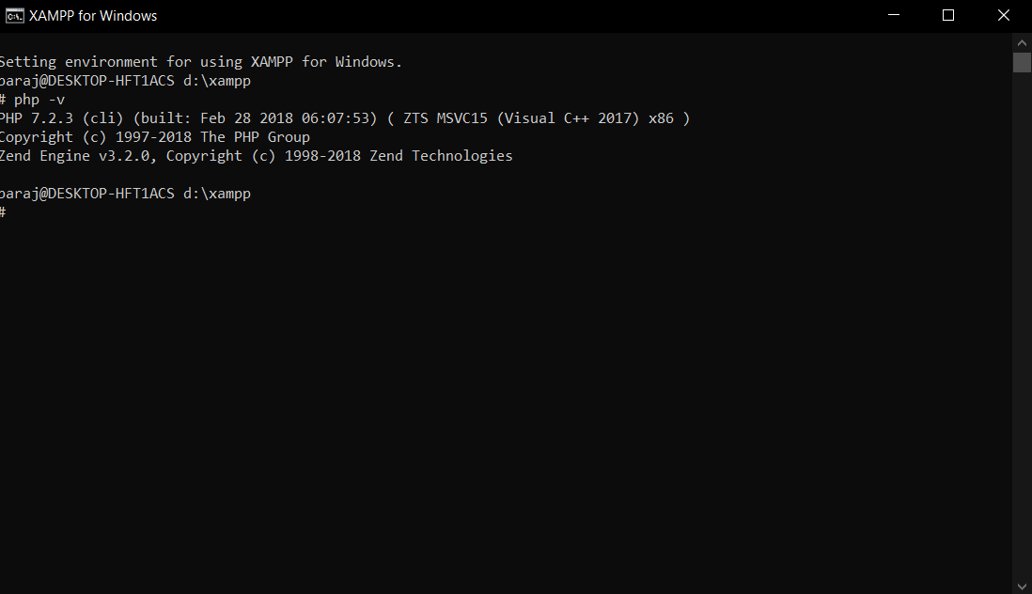
3. After finding out what version your php is go to the link <https://pecl.php.net/package/oci8> and press the DLL link corresponding to the version of php you have. If your php version is greater than 7.1 select the DLL of version 2.2.0.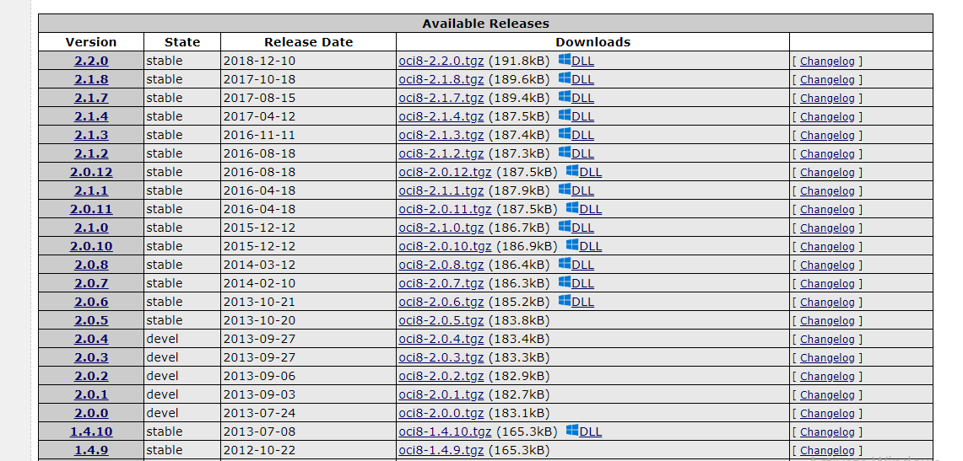
4. Now, you will see a page showing the package information and a DLL list for php versions 7.1. to 7.4. Select and download a thread-safe DLL suitable to the device you are using, in our case it would be [7.2 Thread Safe (TS) x64](https://windows.php.net/downloads/pecl/releases/oci8/2.2.0/php_oci8-2.2.0-7.2-ts-vc15-x64.zip).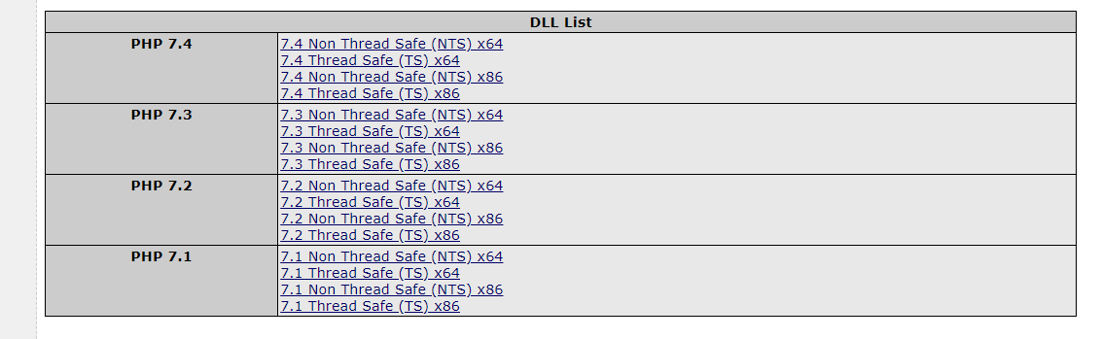
5. Extract the downloaded files to a suitable location and open it.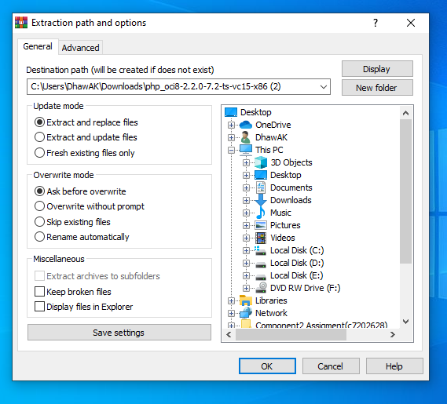
6. Select and copy 2 files from the extracted folder which are php_oci_11g.dll and php_oci_11g.pdb.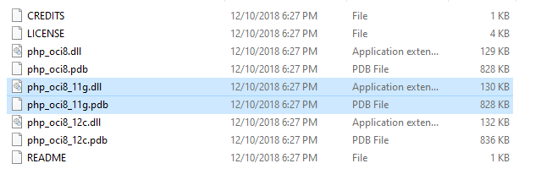
7. After copying the files paste them in the folder xampp -> php -> ext.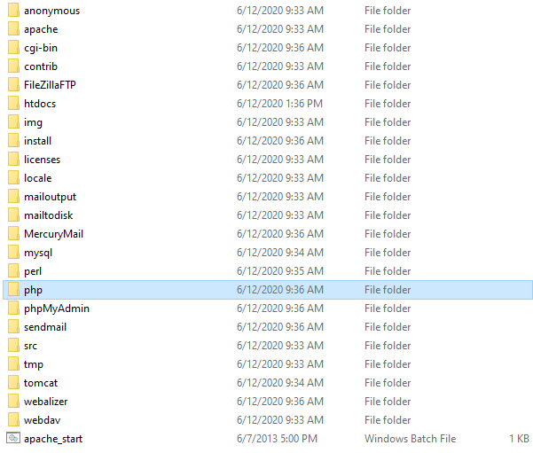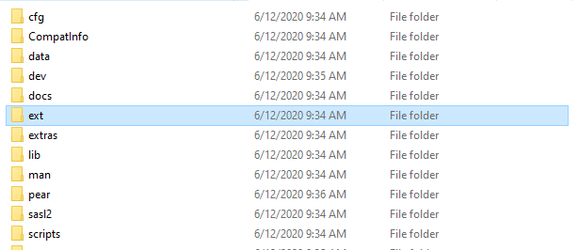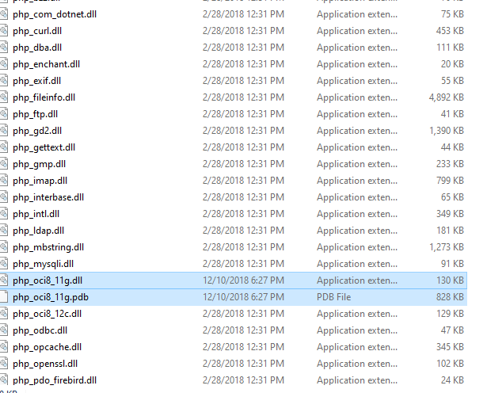
8. Go to the php folder in xampp and within the folder open the php.ini file (preferably open with notepad++).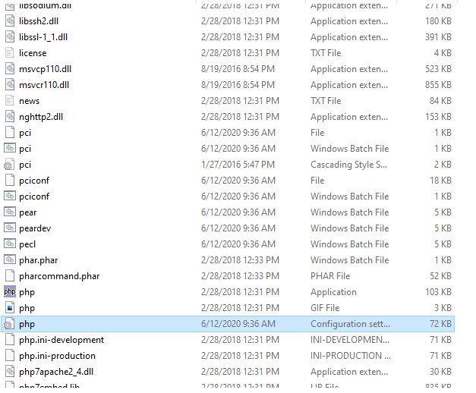
9. Within the file around the line 900 you will see a bunch of extensions, at the bottom of the list type in extension=php_oci8_11g.dll.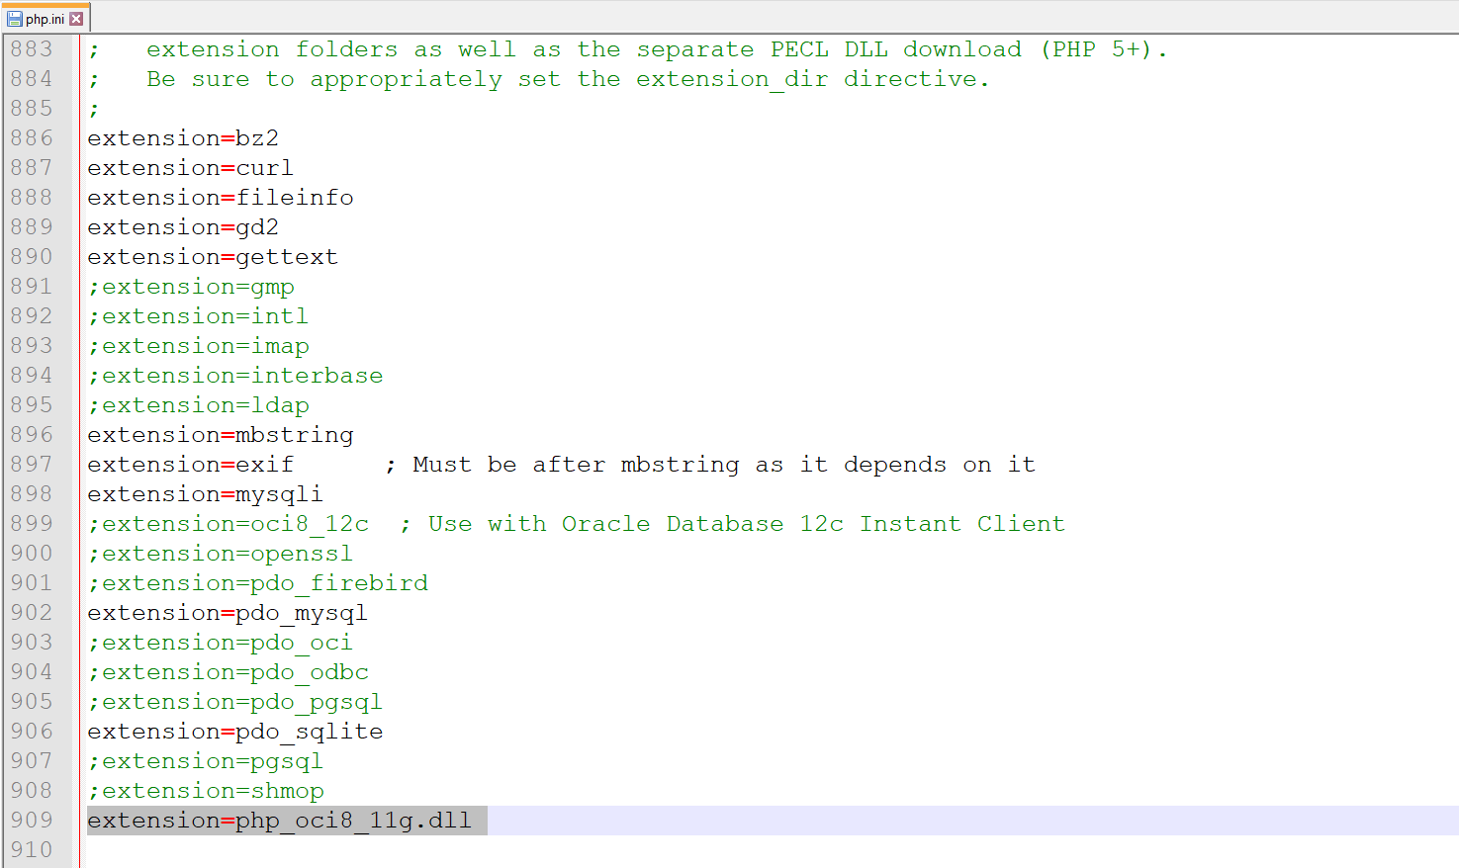

10.After dll extension was added an oracle application which we have installed was opened and it was login by providing username and password used during application installation.

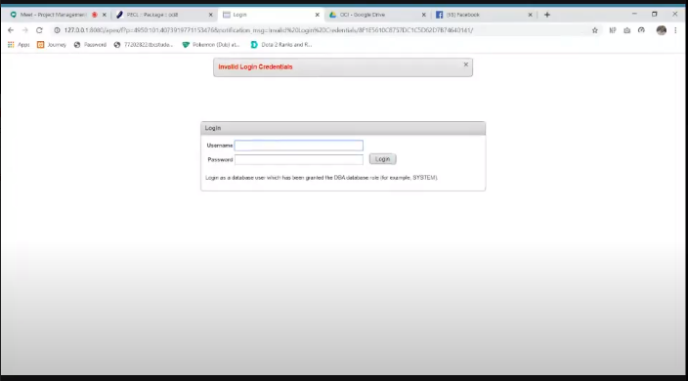

11.After it is login workspace was created which should be communicated by our php code with providing username and password.

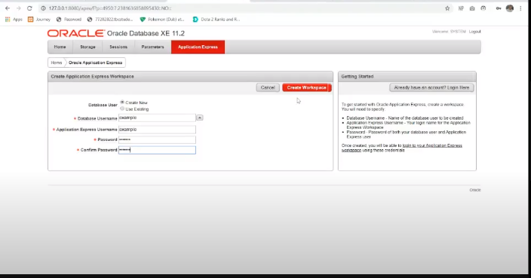

12.After workspace is created we can sign in and open the old version of oracle with username and password which we created to make workspace

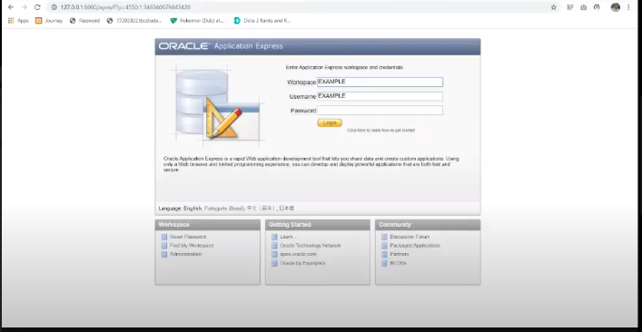

13.our application express will look this way before updating

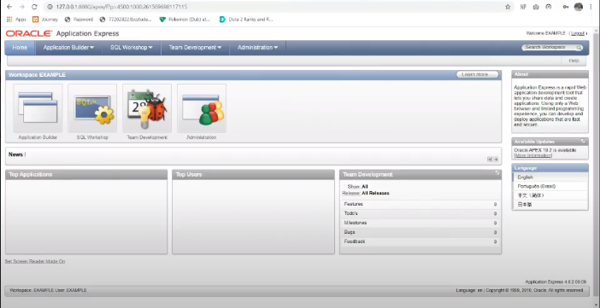

14.After this from files provided in our drive connect.php was downloaded and saved in a folder in htdocs and was edited with workspace name and password provided in oracle in oci_connect in line 1.

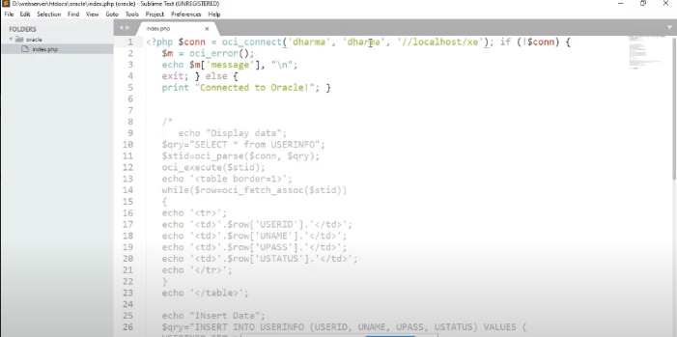

15.After editing connect.php it was run in localhost and connected to oracle msg was observed on screen.



16. After that we are going on send mail folder inside xampp and open send mail config file and do modification on smpt_server mail, smtp_port, smtp_ssl to tls, error log file to this

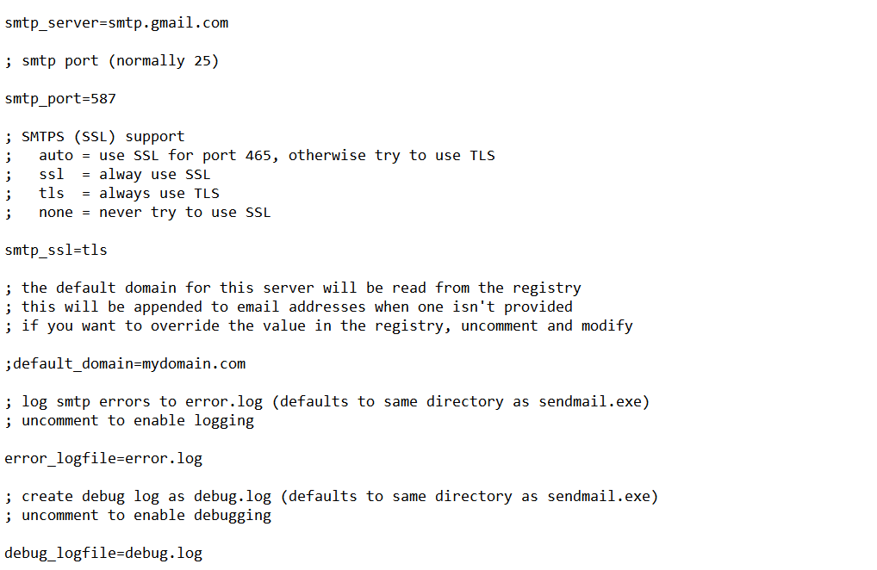

And now we have to do some changes on to the authentication email and password part, force senders to following:

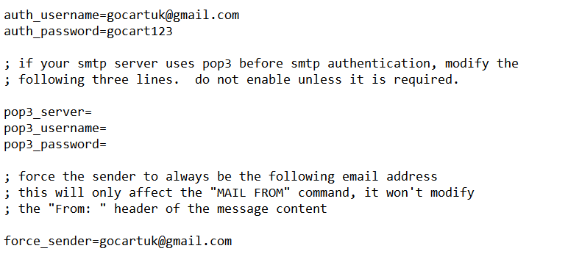

17.  Go to the (D:xampp\php) and open the PHP configuration setting file then find the [mail function] by scrolling down or simply press**ctrl+f** to search it directly then find the following lines and pass these values. Remember, there may be a semicolon ; at the starting of each line, simply remove the semicolon from each line which is given below.

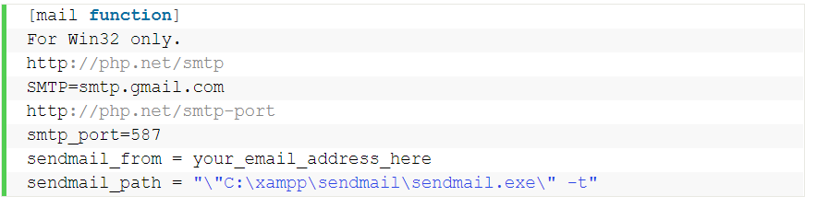

18.Now, go to <https://www.oracle.com/tools/downloads/apex-192-downloads.html> and download oracle APEX 19.2.

17.After the download has been completed extract the apex folder to the C drive.

18.Open command prompt and change the directory to the recently extracted apex folder.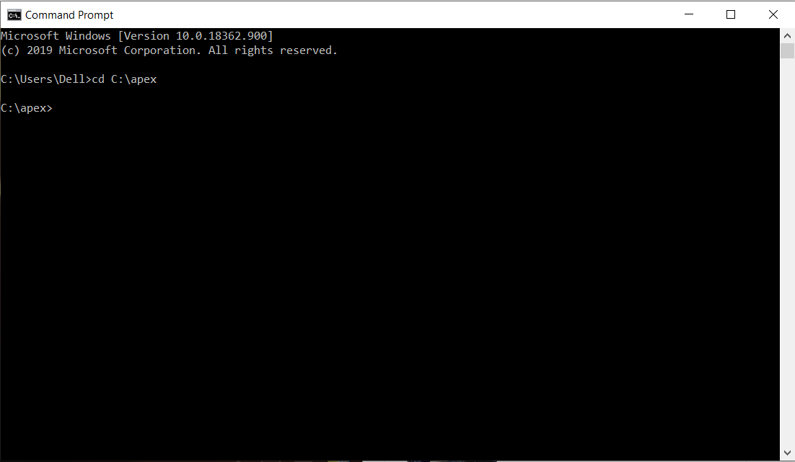

19.Type in and enter ‘sqlplus /nolog’, then type ‘CONNECT SYS as SYSDBA’ and enter your password to connect into the database.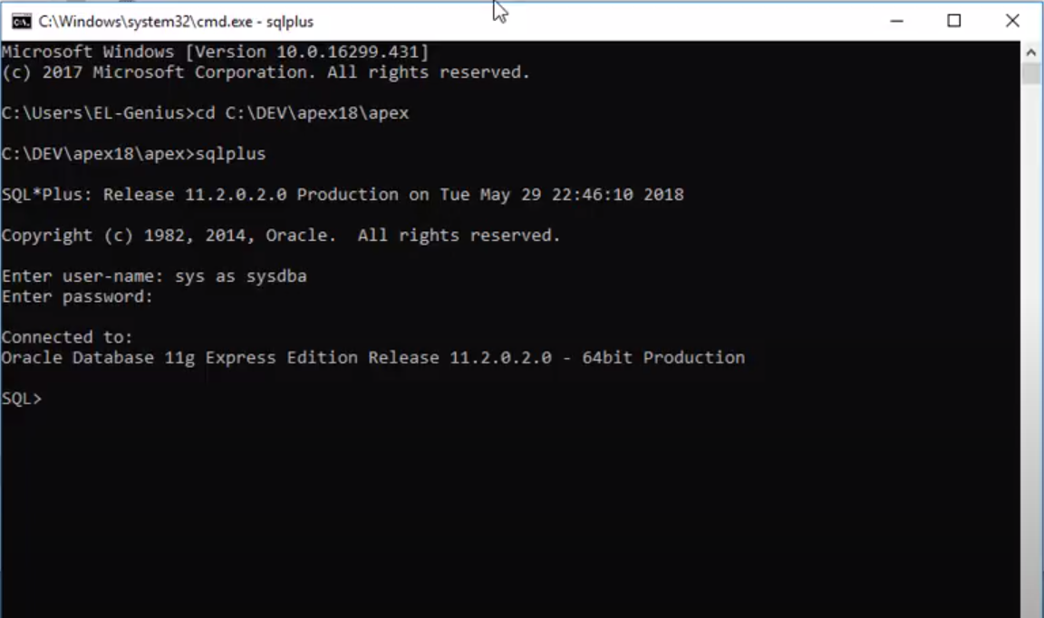

20.Now, enter ‘@apexins SYSAUX SYSAUX TEMP /i/’ to install application expressions. This process will take a few minutes.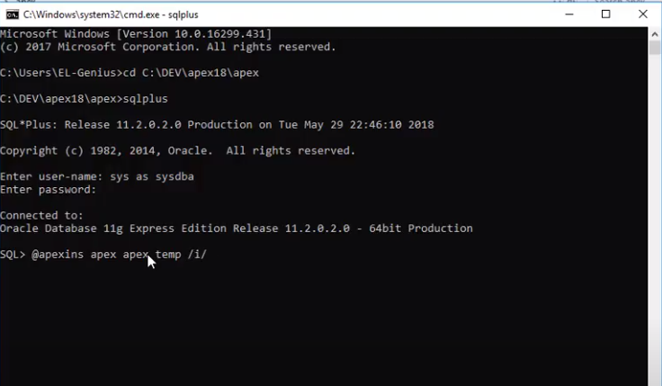

21.After the installation has been completed repeat step 13.

22.Type ‘@apex_epg_config.sql C:\’ to configure the Embedded PL/SQL Gateway (EPG). This process will also take some time.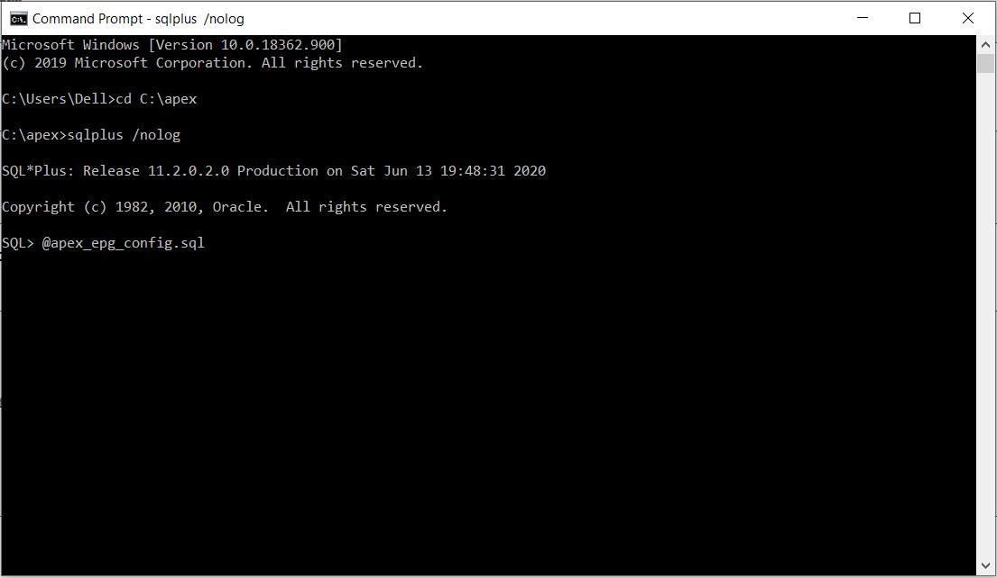

23.If you did everything right the upgrade should have happened and you will receive the following page when you go to <http://127.0.0.1:8080/apex/> or double click on the previously installed oracle database.